Characteristic | N = 135¹
Age (years)
<35 | 23 (17%)
35-45 | 46 (34%)
45-55 | 33 (24%)
55+ | 33 (24%)
Family history of breast cancer | 3 (2.2%)
Stage
Stage 1 | 0 (0%)
Stage 2 | 1 (0.7%)
Stage 3 | 0 (0%)
Stage 4 | 134 (99%)
Molecular subtype
HR+/HER2+ | 15 (31%)
HR+/HER2- | 20 (41%)
HR-/HER2+ | 6 (12%)
HR-/HER2- | 8 (16%)
Histology
Duct cell carcinoma | 47 (35%)
Infiltrating duct cell carcinoma | 74 (55%)
Lobular cell carcinoma | 5 (3.7%)
Infiltrating adenocarcinoma | 2 (1.5%)
Invasive carcinoma | 7 (4.6%)
Grade
Grade 1 | 8 (6.9%)
Grade 2 | 58 (50%)
Grade 3 | 50 (43%)
Lung metastasis | 51 (38%)
Liver metastasis | 13 (9.7%)
Brain metastasis | 55 (41%)
Bone metastasis | 63 (47%)
Opposite-breast metastasis | 14 (10%)
¹n (%)

Characteristic | N = 135¹
Surgery
Mastectomy | 69 (62%)
BCS | 42 (38%)
Chemotherapy received | 125 (93%)
Hormone therapy received | 20 (15%)
Targeted therapy received | 12 (8.9%)
Zoledronic acid received | 50 (37%)
Recurrent metastasis | 72 (75%)
De novo metastatic disease | 62 (47%)
Metastatic burden
1 site | 78 (59%)
2-3 sites | 53 (40%)
>3 sites | 1 (0.8%)
Current disease status
Alive with disease | 78 (58%)
Disease free | 18 (13%)
Death | 39 (29%)
¹n (%)
14(36.8%)Uptake among 38 HR+ Cases
5(23.8%)Uptake among 21 HER2+ Cases
Characteristic | Alive  N = 96¹ | Death  N = 39¹ | p-value²
Tumor grade |  |  | 0.5
Grade 1 | 6 (7.6%) | 2 (5.4%)
Grade 2 | 42 (53%) | 16 (43%)
Grade 3 | 31 (39%) | 19 (51%)
Molecular subtype |  |  | 0.064
HR+/HER2+ | 10 (28%) | 5 (38%)
HR+/HER2- | 17 (47%) | 3 (23%)
HR-/HER2+ | 2 (5.6%) | 4 (31%)
HR-/HER2- | 7 (19%) | 1 (7.7%)
Metastatic burden |  |  | 0.2
1 site | 59 (63%) | 19 (49%)
2-3 sites | 33 (35%) | 20 (51%)
>3 sites | 1 (1.1%) | 0 (0%)
Lung metastasis | 26 (27%) | 25 (64%) | <0.001
Liver metastasis | 4 (4.2%) | 9 (23%) | 0.002
Delayed treatment | 30 (32%) | 26 (68%) | <0.001
Skipped treatment |  |  | <0.001
Non Adherent | 33 (35%) | 29 (74%)
Adherent | 62 (65%) | 10 (26%)
¹n (%)
²Fisher's exact test

 | Univariate analysis |  |  | Multivariate analysis
Characteristic | HR | 95% CI | p-value | HR | 95% CI | p-value
Age Group
<35 | — | — |  | — | —
35-45 | 0.74 | 0.29, 1.89 | 0.5 | 0.75 | 0.06, 8.66 | 0.8
45-55 | 0.74 | 0.27, 2.04 | 0.6 | 0.06 | 0.00, 2.19 | 0.13
55+ | 0.93 | 0.35, 2.50 | 0.9 | 0.00 | 0.00, 0.07 | 0.003
Tumor grade
Grade 1 | — | — |  | — | —
Grade 2 | 1.08 | 0.25, 4.73 | >0.9 | 0.01 | 0.00, 240 | 0.4
Grade 3 | 1.47 | 0.34, 6.34 | 0.6 | 0.51 | 0.00, 10,396 | 0.9
Molecular subtype
HR+/HER2+ | — | — |  | — | —
HR+/HER2- | 0.34 | 0.07, 1.74 | 0.2 | 0.13 | 0.01, 1.33 | 0.086
HR-/HER2+ | 3.49 | 0.74, 16.5 | 0.11 | 128 | 0.89, 18,309 | 0.055
HR-/HER2- | 0.44 | 0.05, 3.76 | 0.5 | 1.51 | 0.00, 23,637 | >0.9
Metastatic burden
1 site | — | — |  | — | —
2-3 sites | 1.77 | 0.92, 3.41 | 0.090 | 18.8 | 0.73, 484 | 0.077
Lung metastasis
No | — | — |  | — | —
Yes | 3.10 | 1.55, 6.20 | 0.001 | 0.11 | 0.01, 2.34 | 0.2
Liver metastasis
No | — | — |  | — | —
Yes | 2.47 | 1.13, 5.43 | 0.024 | 1.56 | 0.19, 13.0 | 0.7
Delayed treatment
No | — | — |  | — | —
Yes | 2.91 | 1.42, 5.93 | 0.003 | 105 | 2.74, 4,005 | 0.012
Skipped treatment
Non Adherent | — | — |  | — | —
Adherent | 0.27 | 0.13, 0.57 | <0.001 | 0.91 | 0.03, 24.5 | >0.9
Abbreviations: CI = Confidence Interval, HR = Hazard Ratio

Figure 1: Kaplan–Meier survival curve of breast cancer patients with brain metastases.
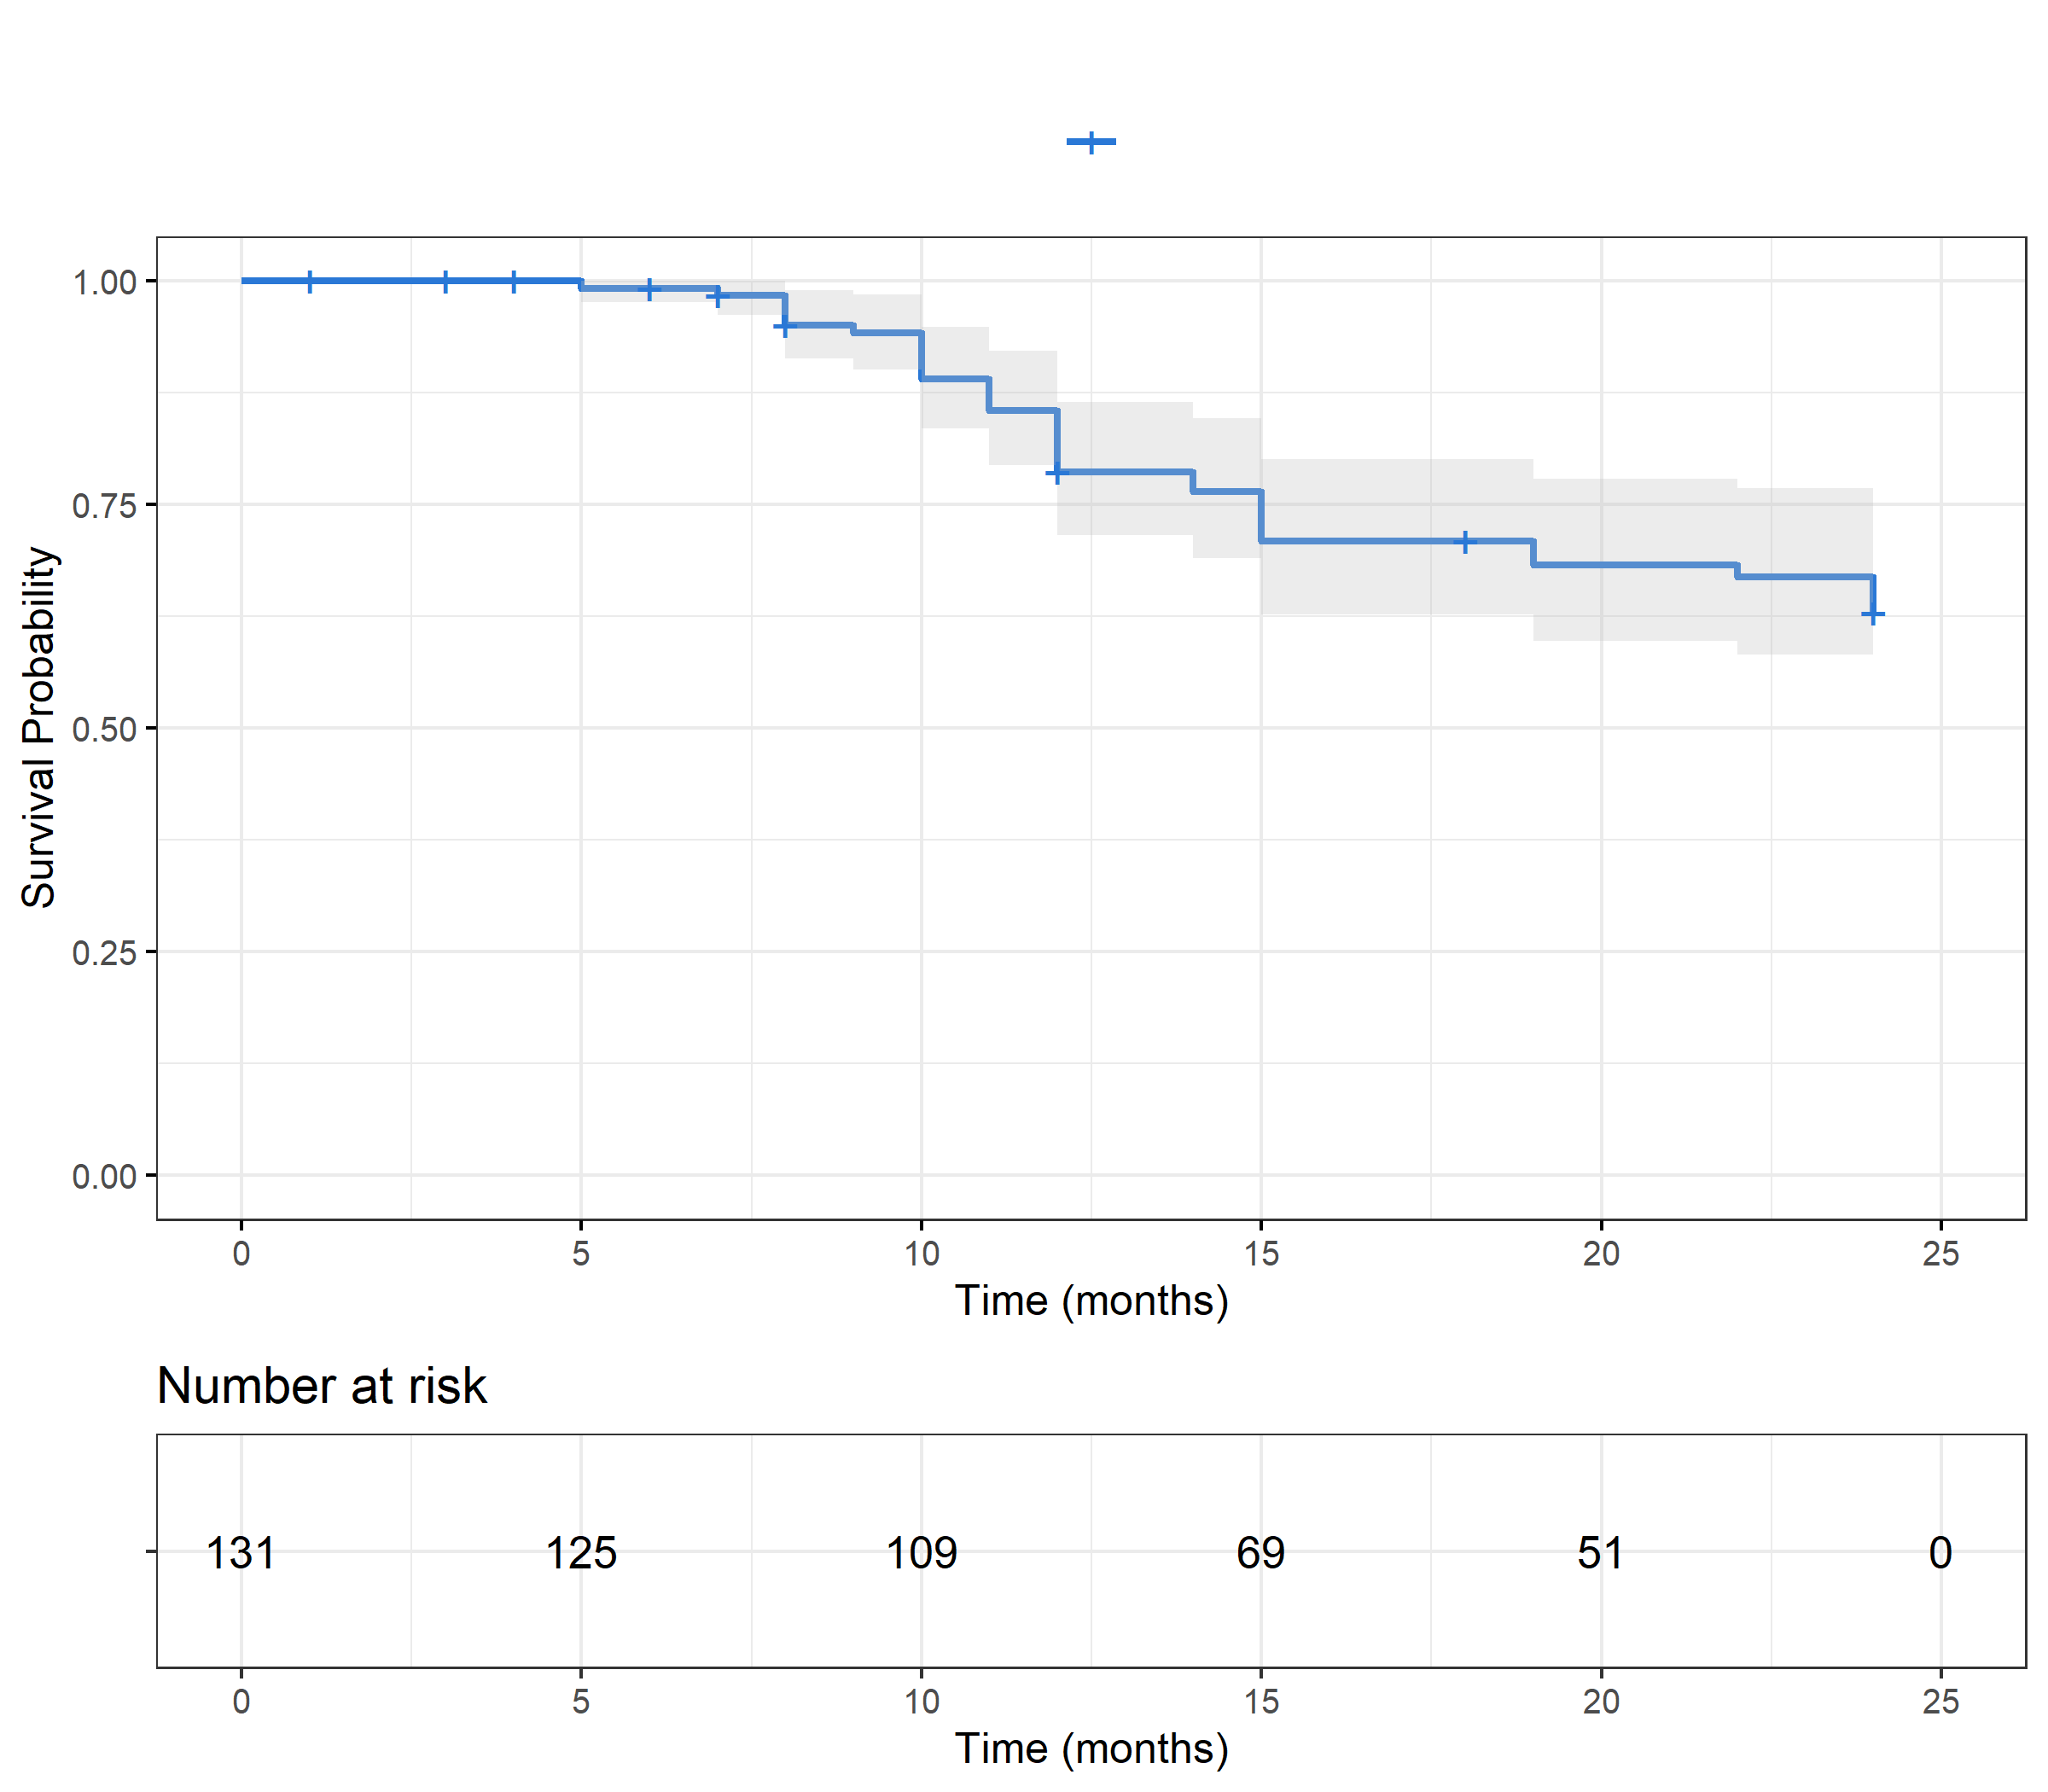

NA Count Within Variables
Vars | NAs
mobile | 28
Duration | 135
DSLT | 135
agecancer | 134
ageofdxfamilybrca | 134
BMI | 135
ageofmenopause | 81
durationocp | 135
durationsymptoms | 11
grading | 19
ps | 13
mburden | 3
surgery | 24
ER | 83
PR | 83
her2 | 86
symptomtometastasis | 6
recume | 39
prestage | 74
ncttaken | 6
delayrx | 4
symptomaticresponse | 6
radiologivcalresponse | 2
timeofdeath | 96
timdea | 96
denovo | 2
mbc_type | 63
clinical_subtype | 83
subtype | 86
os_time | 6

